

Action-packed Pre-Apocalyptic Parcel Delivery

Matt Farrell - B00625174

Johna Latouf - B00698246

Orjan Monsen - B00697153

Robert Tracey - B00699803

*October 17th, 2016*

Table of Contents

**Abstract****2**

**Game Overview****3**

High Concept 3

Genre 3

Hooks 3

License 3

Gameplay Highlights 4

Art and Audio Highlights 4

Hardware 4

**Production Details****5**

Current Status 5

Development Team 5

Matt Farrell 5

Johna Latouf 5

Orjan Monsen 5

Robert Tracey 6

Schedule 6

Sprint 1 6

Sprint 2 6

Sprint 3 6

Sprint 4 7

**Competition****7**

Crazy Taxi 7

Mirror’s Edge Catalyst 7

Gravity Rush 2 8

**Game World****8**

Backstory 8

Objective 9

Characters 9

Story Progression 10

Monday: Introduction 10

Tuesday: The Postal Service 10

Wednesday: The Storm 10

Thursday: Full Postal War 10

Friday: The Apocalypse 11

**Appendix A: Concept Artwork****12**

**Appendix B: References****14**

# Abstract

*One Day Delivery* is a new fast-paced arcade-style platformer. You play as Larry Noodleman, fledgling delivery man for the company *One Day Delivery*. Larry has lived his entire life with a set of unfortunately long, lanky, elastic limbs. Together with his boss and dispatcher, Larry must strive to deliver all packages within one day, while also fighting with the local Postal Service, and avoiding angry drivers and ferocious neighbourhood dogs.

*One Day Delivery* brings exciting gameplay to a cartoonish world where everything is a race against the clock. Each of the five workdays task Larry with with a new set of obstacles, ranging from a disastrous hurricane to a postal apocalypse.

# Game Overview

## High Concept

*"Neither snow nor rain nor heat nor gloom of night stays these couriers from the swift completion of their appointed rounds"*

**~ United States Postal Service**

You are fledgling delivery man Larry Noodleman, on the first day of your job at the *One Day Shipping* package delivery service. Use your unfortunately disproportionate limbs to deliver people’s packages. Beat the clock, avoid competing postal workers, and try to survive your first week of work.

Along the new work week, face challenges from the environment and disgruntled Postal Service employees out to besmirch your name.

## Genre

*One Day Shipping* finds its roots in some of the best high speed physics-based arcade-style platformers. It’s pace of gameplay and controls are akin to games like *Crazy Taxi*, *Super Monkey Ball*, and a history of 3D platformers with responsive and dynamic controls. Each level of *One Day Shipping* augments the game environment, increasing the difficulty.

## Hooks

The player must engage in a mundane job in a comically wacky way. The game encourages destructive, dangerous behaviour.

The player is subject to pseudo-realistic physics, but has the ability to stretch his limbs and perform gymnastics to reach goals.

A changing game world that introduces new challenges and obstacles keeps the player entertained.

## License

While the game won’t have any licensed characters or story, we will make use of some ready-made assets. Dog characters can take advantage of the rig found on CG Trader. We are also considering purchasing a low-poly dog model with bipedal animation from the Unity Asset store.

Human models will use rigs and animation provided for free from the Unity Asset Store. Photorealistic textures will include images from http://www.freeimages.com.

*One Day Shipping* will also take advantage of Pixar’s released library of 128 repeating textures.

## Gameplay Highlights

**Satisfying physics collisions** between Larry Noodleman and the rest of the game world.

**Hilarious player animations** as Larry scampers around the game world.

**Intense race against the clock gameplay**.

**Comical NPC dialog** in between levels.

**High score system** that gives skilled players a goal to work for.

**Randomized spawn locations of power-ups and enemies** that make the game replayable.

**Relatable characters** that each have an important role in progressing the story.

**Responsive and intuitive player controls** that allow the player to maneuver the hectic game world.

**Creative level design** allows the player reach their goal in many different ways.

**Entertaining story progression** that keeps the player motivated to complete the game.

## Art and Audio Highlights

Our team includes developers with artistic backgrounds that will allow us to create or modify existing art assets and animations. This will give *One Day Shipping* a unique appearance versus other indie games. Characters and sets will have a cartoonish, Pixar-like appearance. Textures will be semi-photo realistic. Dialog will be text-based with audio “stings”, meaning characters will have short sound-bytes associated with their lines.

## Hardware

This game will be compatible on current Windows PC and Apple computers. The game will be tuned for a standard keyboard control setup, but will be able to be played with a game controller peripheral as well.

# Production Details

## Current Status

We have completed a prototype demonstrating the character physics and movement. This includes a temporary humanoid character holding a parcel in his hands. A sphere wraps around the humanoid, representing the detection area around the player for interacting with other game objects (Appendix A-1).

We have completed mock-ups demonstrating the main character looks and behaviour. This includes images that the main character has been based on, coloured images of the potential main character, and sketches of the main character in full motion, showing his lanky body-type in great detail (Appendix A-4).

## Development Team

### Matt Farrell

Matt is currently a computer science student at Dalhousie. He has 8 months of experience as a software developer working for the companies Protocase and MDA.

Matt will contribute to level design, camera control, presentations, gameplay testing, and bug reports.

### Johna Latouf

Johna has seven years experience working as a video game graphic artist at HB Studios. She has designed UI art assets primarily for EA Sports titles including multiple versions of Madden Wii and PS3/Xbox 360 and Fifa titles. She has also worked as a Software Developer at Lloyd’s Register ATG, programming desktop applications for use by engineers. She is currently a third year Computer Science student at Dalhousie specializing in Graphics, Gaming, and Media and a Research Assistant, helping with the development of web applications at the Institute for Big Data Analytics at Dal.

Johna will contribute to 3D modelling and texturing, gameplay programming, and interaction design.

### Orjan Monsen

Monsen is responsible for the programming development of the GUI, game play, and camera controls, as well as testing of each level and filing bug reports. He has previously worked as a Software Developer at Gracenote, and has experience programming API endpoints as well as website widgets in Javascript. He is also a current third-year student at Dalhousie University majoring in computer science and minoring in mathematics. A few of his academic course projects includes implementing the Enigma Machine in Java, code analysis of CGSuite, and creating a Researcher application that tracks students’ movement on their respective campuses in Java using Vaadin.

### Robert Tracey

Robert is currently a graphics and optimization programmer at Ubisoft Halifax where he works in the Unity environment to develop games for mobile platforms. Robert has seven years experience in the theatre industry, where he worked as a lighting, sound, and projection designer, and also specialized in production management.

Robert will be programming shaders and visual effects for the game. He will also be contributing to programming the gameplay elements, and assuring the graphical optimization of the game.

## Schedule

The project development workflow strategy will be Agile (Scrum), including two-week sprints and bi-weekly sprint meetings. Daily standups will be practiced every time the development team meets up to work on the project. The final ship date is December 6th, 2016, which means there will be three full sprints followed by a fourth sprint that only lasts for 9 days. Below is a rough plan of what details needs to be completed at the end of each sprint.

### Sprint 1

Set up game systems and event managers.

Main character should be completed. He should have a character controller, the camera should follow him, and he should be fully equipped with animations.

The first level should have terrain and additional objects / features such as buildings, trees etc.

### Sprint 2

The AI characters should be completed. This includes the Boss, the Dispatcher, the Neighbourhood Dogs, and the Cars.

The first level should be 100% completed.

### Sprint 3

The 2nd, 3rd and 4th levels should be completed.

The first level should be tested properly, and optimization / bug fixes should be completed.

### Sprint 4

The 5th level should be completed

The 2nd, 3rd, 4th, and 5th levels should be tested properly, and optimization / bug fixes should be completed.

Full game polish, small adjustments and tweaks should be completed.

# Competition

## Crazy Taxi

Crazy Taxi, originally developed by Hitmaker, is a series that began in arcades in the late 1990’s and was ported to a console game in 2000. More recently, it has expanded to the mobile market. The game requires a single player to act as a taxi driver, picking up fares and earning money while speeding through wacky road conditions and scenarios. Players can “Barrel through traffic packed streets, hurdle off parking garages, and crazy combo your way to crazy money” (SEGA, 2015). IGN describes it as “a spastic and breakneck romp through an open-world city”. Players must master control sequences to move quickly through the world to earn points (Davis, 2012).

The latest release of Crazy Taxi Classic for mobile devices currently has a 4.0 on Android and iOS, where it is priced $5.76 and $6.99, respectively, and it has between 100,000 and 500,000 installs on Android alone. It includes extra features like the ability to listen to your own music, and 16 mini-games. While the game is for a single player, like most mobile games, it includes social leaderboards (SEGA America, 2014). Crazy Taxi for iOS boasts a 78 on Metacritic.

Crazy Taxi, like *One Day Shipping*, takes a mundane job and makes it funny using physical gags and absurd behaviour. It rewards the player for reckless and comical actions and makes use of exaggerated physics and short time-limits.

## Mirror’s Edge Catalyst

The Mirror’s Edge franchise features a single player who engages in parkour across a futuristic, dystopian city to complete quests and make deliveries. The game uses a first person perspective and minimal UI to add a sense of realism. While this game relies on a large story-arc, it also includes multiple time-trials, many of which revolve around delivering items. The game focuses on speed, gymnastics, and evasion, rather than combat.

Catalyst, released in 2016, received a 69 on Metacritic. IGN’s review cites the weak storyline as a disappointment, but it praises the ability to make your own time-trials. The game rewards players with advanced storylines and unlockable moves, skills, and gear (McCafrey, 2016).

Given its recent release, Catalyst is a reasonable competitor for *One Day Shipping*, but it lacks a sense of comedy or exaggeration. IGN’s reviewer found the game’s storyline unenjoyable and the characters unlikable (McCafrey, 2016). *One Day Shipping* will likely provide a more entertaining experience for players looking for a physics and time based platformer that is a little less dreary.

## Gravity Rush 2

Gravity Rush 2 is a 3D platformer adventure scheduled for release in 2017. The game uses gravity effects to create a puzzle-like platformer. This game is more story-based than comedic (Dutka, n.d.). The original Gravity Rush has an 80 on Metacritic and is available on handheld and console platforms. Like *One Day Shipping*, this game appeals to players of 3D, highly physical platformers, but it lacks the destructive wackiness.

# Game World

## Backstory

Larry Noodleman is a young man with the unfortunate problem of having long, lanky, elastic limbs his entire life. Because of his condition, Larry has never been able to hold down a steady job. Every time Larry has attempted a career, his limbs have caused (as one co-worker put it in a recent accident report) a “hostile working environment”.

Now Larry has a chance to redeem himself at the city’s newest package delivery company: One Day Shipping. Larry is the first delivery man for the new company and, as The Boss constantly reminds him, “everything is on you”.

The Boss has his sights set on success. He grew up in a family of entrepreneurs, and now it is his turn to make a name for himself and join the family legacy. He decided to create One Day Shipping after noticing a lack of delivery services in the area. In fact, there is only one competitor in the market: the Postal Service.

There is a good reason that there is only one other delivery company. The Postal service has been ruling over the mail delivery world since the invention of the postage stamp. They are an elite, exclusive club of the who’s who of the delivery community. Any time competition has sprung up, the Postal Service has beat them back down. But they’ve never faced a delivery man like Larry Noodleman, and One Day Delivery is bound to rattle their chains.

## Objective

Larry is a new employee to the *One Day Shipping* company, and as such must prove himself a worthy employee in his new job. What’s more, Larry’s company has a special claim: each package must be delivered in one day. If Larry fails to deliver a package, the lost money comes off of his paycheque.

As the sole delivery man, the success of the business is directly related to his work. To keep Larry working at the top of his abilities, the Boss has implemented a per-day work quality report. Larry gets a letter grade at the end of every day reflecting how well he did. If he misses a package, that’s a ding to his grade. If packages get damaged by obstacles, that will hurt his score as well.

## Characters

The game world is populated with a number of quirky characters, each of which has different traits.

**Larry Noodleman:** Your character and postal hero. Larry is cursed from birth with unfortunately long, lanky, and elastic limbs. Having spent many years failing at a number of jobs, has Larry finally found his calling?

**The Boss:** Owner of the *One Day Shipping* package delivery service, and local entrepreneur. The Boss comes from a family tradition of loud-mouthed employers. His sole goal is to make sure his new company becomes the greatest delivery service in the world.

**The Dispatcher:** Your connection to the package delivery world. A confidant and local gossip, the dispatcher fills you in on the goings-on of the business and the city, informing you of packages that need delivery and teaching you techniques to complete your route.

**The Postal Service:** Each story needs a good enemy, and none is more frightening than the Postal Service. This shady corporation has ruled the delivery world, and do not take lightly to your advances on their turf. These agents want to sabotage your good work, and will try their best to slow you down. As your business gets more successful, they become more aggressive and hatch devious plots.

**Angry Drivers:** This town is known as the ‘Road Rage Capital’, and the drivers certainly exhibit it. Constantly angry, annoyed, and in a hurry; these drivers definitely won’t stop for a delivery person, and will hit you hard.

**Neighbourhood Dogs:** The cat and the mouse. The fox and the hen. The dog and the delivery person. All creatures have a natural predator, and these animals are yours. The dogs in this city have a bad reputation for hurting delivery persons, and you are no exception!

## Story Progression

Larry has to complete five work days in order to get through the week. Each day comes with a new set of challenges and a ramped-up difficulty.

### Monday: Introduction

At the start, *One Day Shipping* is a relatively unknown package delivery system. This is a tutorial level to give a player a feel for the game, and will be full of onboarding to help demonstrate how each action occurs.

On this day, Larry is just starting out, and is getting a lot of help from his new coworker, the Dispatcher. The number of packages is relatively high, and Larry delivers them with his signature lanky style.

This oddity of the delivery world gets picked up by local media outlets, and suddenly *One Day Shipping* is inundated with calls.

### Tuesday: The Postal Service

The media attention of *One Day Shipping* has caused a huge influx of work, and everyone is taking notice. This includes the Postal Service. As the day is starting out, a fancy black envelope with a gold stamp is delivered to the door. The Dispatcher recognizes it immediately: a threat from the Postal Service!

During this day, the Postal Service employees are introduced. They will try to stop Larry from finishing his deliveries, and will even attempt to steal or destroy your packages.

### Wednesday: The Storm

A massive weather event is affecting the city, and *One Day Shipping* is tasked by the Mayor’s office to deliver much-needed relief umbrellas to the citizens.

This level incorporates weather mechanics to affect player movement. The player must deal with these new physics - wind forces and slippery water patches - to complete their deliveries.

### Thursday: Full Postal War

The storm has subsided and the city has lauded *One Day Shipping* as the heroes. This extra attention does not sit well with the Postal Service, and they retaliate with a violent street war. It is Larry against an army of Postal Service employees, and they are out for vengeance.

You have to deliver packages because it’s your job. The Postal Service, in their focus on you, fails to deliver a single package and loses their reputation in the community.

### Friday: The Apocalypse

After their defeat at the hands of Larry, the Postal Service implements their scorched earth tactic and begins raining flaming packages from the sky. But Larry is a Postal Worker, and must finish his job of delivering packages.

# Appendix A: Concept Artwork

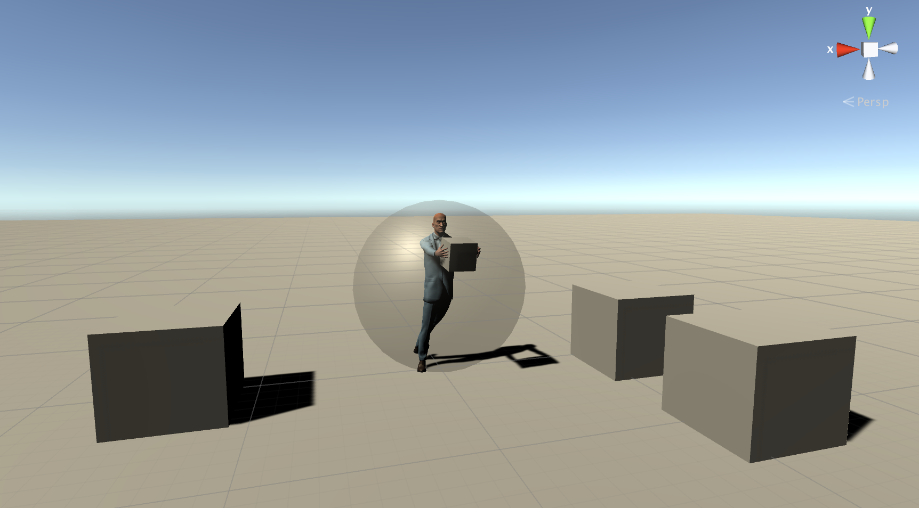

Figure 1: Main-character Prototype

 

Figure 2: Mock-up of the dispatcher character Figure 3: Mock-up of the game logo

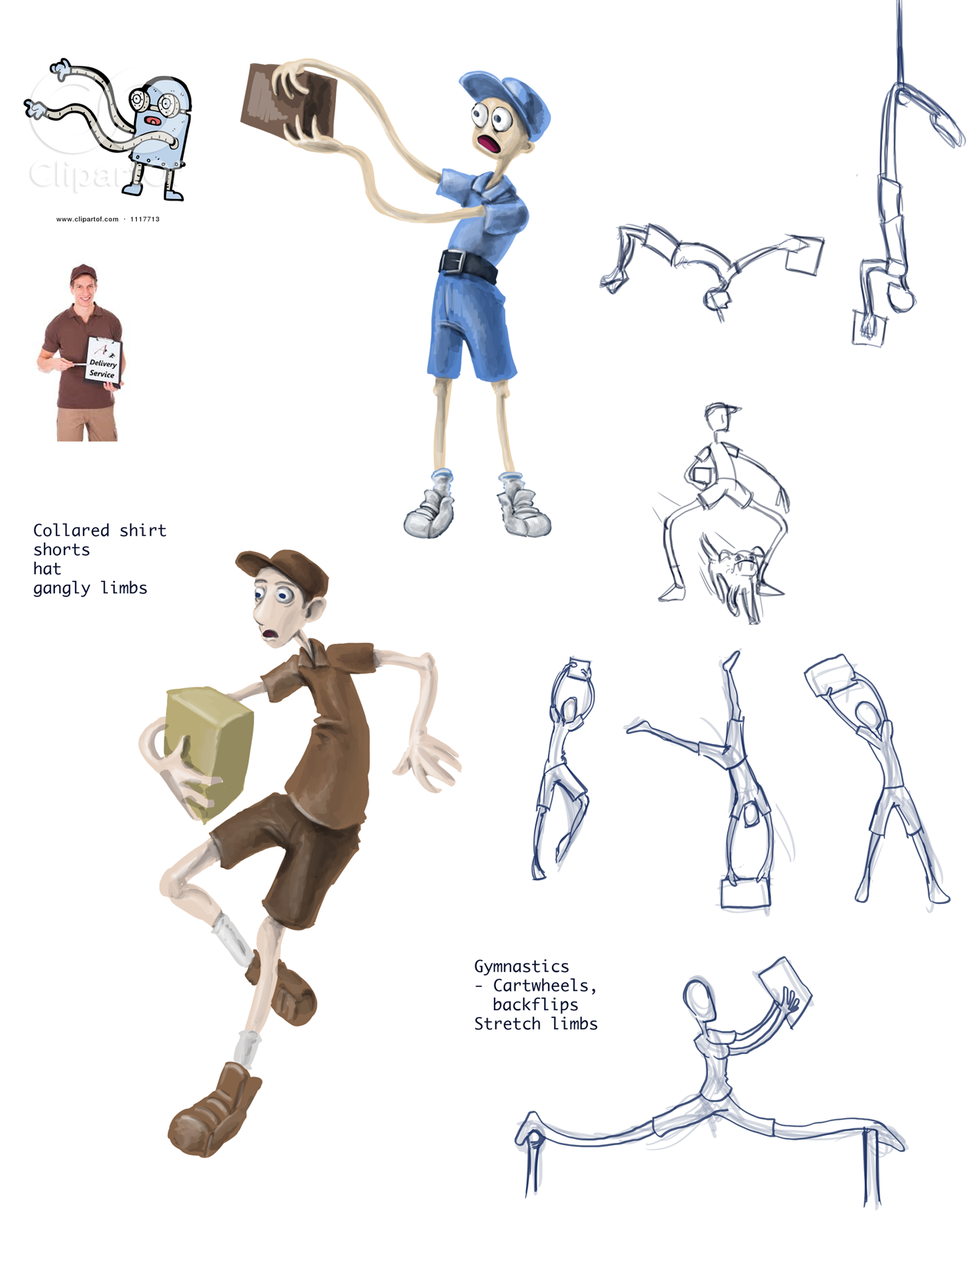

Figure 4: Mock-ups of the main character and his movements. Clipart from ClipartKid, A+ Delivery

# Appendix B: References

Clipart Kid. (n.d.). Retrieved October 17, 2016, from http://www.clipartkid.com/cartoon-arms-clip-art-vector-cartoon-robot-with-long-Wz2APT-clipart/

[Clipart of Deliver Guy] Retrieved from http://www.aplusdelivery.net/wp-content/uploads/2014/02/Delivery-Guy-with-Logo.jpg

Davis, B. J. (2012, October 11). Crazy Taxi Review - IGN. Retrieved October 16, 2016, from http://ca.ign.com/articles/2012/10/11/crazy-taxi-review-2

Dutka, B. (n.d.). Gravity Rush 2 Preview. Retrieved October 16, 2016, from http://www.psxextreme.com/ps4-previews/86.html

McCaffrey, R. (2016, June 06). Mirror's Edge Catalyst Review - IGN. Retrieved October 16, 2016, from http://ca.ign.com/articles/2016/06/06/mirrors-edge-catalyst-review

SEGA America. (2014, March 14). Crazy Taxi on the App Store. Retrieved October 16, 2016, from https://itunes.apple.com/ca/app/crazy-taxi/id553921725?mt=8

SEGA (2015, July 06). Crazy Taxi Classic - Android Apps on Google Play. Retrieved October 16, 2016, from https://play.google.com/store/apps/details?id=com.sega.CrazyTaxi